

DataWarehouse and DataMining

TITLE
- commerse product recommendation system

PROJECT REPORT

Slot-F2+TF2
School of Computer Science and Engineering

By
23BCE9836 | G.Sharun
24BCD7127 | Raghava

Submitted to:
Dr.Bethany Gosala
Assistant Professor sr.Grade-1

TABLE OF CONTENTS

S.No. | Title | Page No.
1 | Abstract | 3
2 | Introduction | 3-4
3 | Problem Statement | 4
4 | Objective | 4
5 | Methodology  5.1 Data Collection  5.2 Data Preprocessing  5.3 Models Used  5.4 Hybrid Model | 5-6
6 | Results and Analysis | 7-10
7 | Conclusion | 11
8 | References | 12

Abstract
The rapid expansion of e-commerce platforms has resulted in a vast increase in product choices, leading to information overload for users. Traditional recommendation systems often struggle with issues such as data sparsity, cold-start problems, and limited personalization. This project proposes a Hybrid E-commerce Product Recommendation System that combines Collaborative Filtering and Association Rule Mining to address these challenges and improve recommendation quality.
The system employs User-Based Collaborative Filtering to capture user preferences by analyzing similarity patterns in user-item interactions. This approach enables personalized recommendations based on the behavior of similar users. However, Collaborative Filtering alone is limited when dealing with sparse data or new users. To overcome this limitation, the FP-Growth algorithm is integrated to mine frequent itemsets from transaction data and generate association rules, enabling the system to recommend products that are frequently purchased together.
Data preprocessing techniques such as data cleaning, handling missing values, and transformation are applied to ensure high-quality input for model training. The hybrid model combines the strengths of both techniques to enhance recommendation accuracy, diversity, and robustness.
The system is implemented using Python, utilizing libraries such as Pandas, NumPy, and Scikit-learn. It generates top-N product recommendations based on user input. Experimental observations indicate that the hybrid approach outperforms standalone methods by providing more relevant and diverse recommendations.
This system can be effectively applied in real-world e-commerce platforms to enhance user experience, increase customer engagement, and drive business growth.

Introduction
The growth of e-commerce platforms such as Amazon and Flipkart has significantly transformed the way consumers purchase products. With millions of items available online, users often face difficulty in identifying products that match their preferences. This problem, commonly referred to as information overload, reduces user satisfaction and makes the decision-making process complex.
To address this challenge, recommendation systems have become an essential component of modern e-commerce platforms. These systems analyze user behavior, preferences, and past interactions to provide personalized product suggestions. By presenting relevant items, recommendation systems not only improve user experience but also increase customer engagement and sales.
Various recommendation techniques have been developed, including Collaborative Filtering, Content-Based Filtering, and Hybrid approaches. Collaborative Filtering relies on user-item interaction data to identify similarities among users and recommend products accordingly. However, it often suffers from limitations such as data sparsity and cold-start problems. On the other hand, Association Rule Mining techniques, such as the FP-Growth algorithm, identify relationships between products based on transaction data, enabling the system to recommend items that are frequently purchased together.
This project focuses on developing a Hybrid E-commerce Product Recommendation System that combines the strengths of Collaborative Filtering and FP-Growth. The hybrid approach aims to improve recommendation accuracy, overcome the limitations of individual methods, and provide more diverse and relevant product suggestions.
The system is implemented using Python and incorporates data preprocessing techniques to ensure high-quality input. It generates top-N recommendations tailored to user preferences, making it suitable for real-world applications in e-commerce platforms. This project demonstrates how integrating multiple recommendation techniques can lead to more efficient and intelligent recommendation systems.

Problem statement
Modern e-commerce platforms host a vast number of products, making it increasingly difficult for users to efficiently identify items that match their preferences. The abundance of choices leads to information overload, which negatively impacts user experience and decision-making.
Existing recommendation systems often face significant challenges, including data sparsity due to limited user interactions, cold-start problems for new users and products, and a lack of balance between personalization and relevance. Many systems fail to simultaneously capture individual user preferences and meaningful relationships between products, resulting in recommendations that are either too generic or insufficiently accurate.
These limitations highlight the need for an improved recommendation mechanism that can effectively handle large-scale data, provide relevant suggestions, and enhance overall user satisfaction in e-commerce environments.

Objective
The main objectives of this project are:
- To design and develop an efficient product recommendation system for e-commerce platforms.
- To analyze user behavior and preferences based on historical interaction data.
- To implement Collaborative Filtering for generating personalized recommendations based on user similarity.
- To apply the FP-Growth algorithm to identify frequent itemsets and discover relationships between products.
- To integrate multiple recommendation techniques into a hybrid model to improve overall recommendation quality.
- To generate top-N product recommendations that are relevant and useful to users.
- To enhance recommendation accuracy, diversity, and user satisfaction.
- To handle challenges such as data sparsity and cold-start problems to some extent.
- To evaluate the effectiveness of the recommendation system based on observed results.

Methodology
The methodology describes the step-by-step process followed to design and implement the recommendation system. It includes data collection, preprocessing, model development, and integration into a hybrid recommendation framework.

5.1 Data Collection
The dataset used in this project consists of user-product interaction data collected from an e-commerce environment. It includes information such as user IDs, product IDs, ratings or purchase history, and transaction records.
This data serves two purposes:
- To analyze user behavior and preferences
- To identify relationships between products based on purchase patterns
The dataset is structured in a tabular format, making it suitable for data analysis and model building.

5.2 Data Preprocessing
The dataset used in this project was already structured and contained minimal noise; therefore, extensive data cleaning was not required. However, preprocessing was performed to optimize the dataset for efficient model execution.
The following steps were implemented:
- User Filtering (Data Reduction):
The most active users were selected using frequency counts. Only the top users (based on number of interactions) were retained to reduce sparsity and computational complexity.
- Merging Datasets:
The orders and order_products datasets were merged using a common key (order_id) to create a unified dataset containing both user and product information.
- Product Filtering (Data Reduction):
Frequently purchased products were selected by filtering top products based on occurrence. This step helps remove rarely occurring items that contribute to noise.
- Data Transformation:
The processed data was structured into a suitable format for:
  - User-item interaction matrix (for Collaborative Filtering)
  - Transaction format (for FP-Growth algorithm)
These preprocessing steps significantly reduced dataset size, improved computational efficiency, and enhanced the quality of recommendations by focusing on relevant users and products.

5.3 Models Used
The recommendation system utilizes two primary models: FP-Growth for association rule mining and Collaborative Filtering using cosine similarity. These models capture both product relationships and user behavior.

a)FP-Growth Algorithm
FP-Growth is used to identify frequently purchased product combinations from transaction data.
- Transactions are created by grouping products using order_id
- Data is converted into one-hot encoded format using TransactionEncoder
- Frequent itemsets are generated using a minimum support threshold (0.02)
- Association rules are derived using confidence (0.1)
- Only single-item rules are retained
Purpose: Recommends products that are commonly bought together

b) Collaborative Filtering
Collaborative Filtering is used to generate personalized recommendations based on user interactions.
- User and product IDs are encoded into numerical values
- A sparse user-item matrix is created using coo_matrix
- Cosine similarity is computed between products
Purpose: Recommends products based on user behavior and similarity

5.4 Hybrid Model
To improve recommendation quality, a hybrid model is developed by combining Collaborative Filtering and FP-Growth outputs.
- Collaborative Filtering generates similarity-based scores between products
- FP-Growth provides association-based recommendations with confidence values
Both outputs are combined using a weighted approach:
- CF contribution is controlled by parameter α (alpha = 0.7)
- FP-Growth contribution is weighted as (1 − α)
The final recommendation score is calculated by merging both contributions and ranking products accordingly.

Key Steps:
- Normalize CF similarity scores
- Add weighted CF scores to final ranking
- Incorporate FP-Growth confidence scores
- Sort products based on final score
- Return top-N recommended products

Purpose:
- Improves accuracy by combining personalization and item relationships
- Provides more relevant and diverse recommendations
Result And Analysis
The system generates product recommendations based on user input. Below are sample outputs:
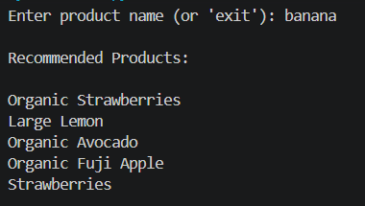
The entered product does not exist in the dataset used by the system.
Hence, no recommendations can be generated for the given input.

The product exists in the dataset but was excluded during preprocessing and model training.
This occurs due to filtering of less frequent items to improve performance and reduce sparsity.
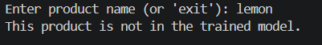
Graphs
- Top products bar chart
Bar chart of most frequently purchased products
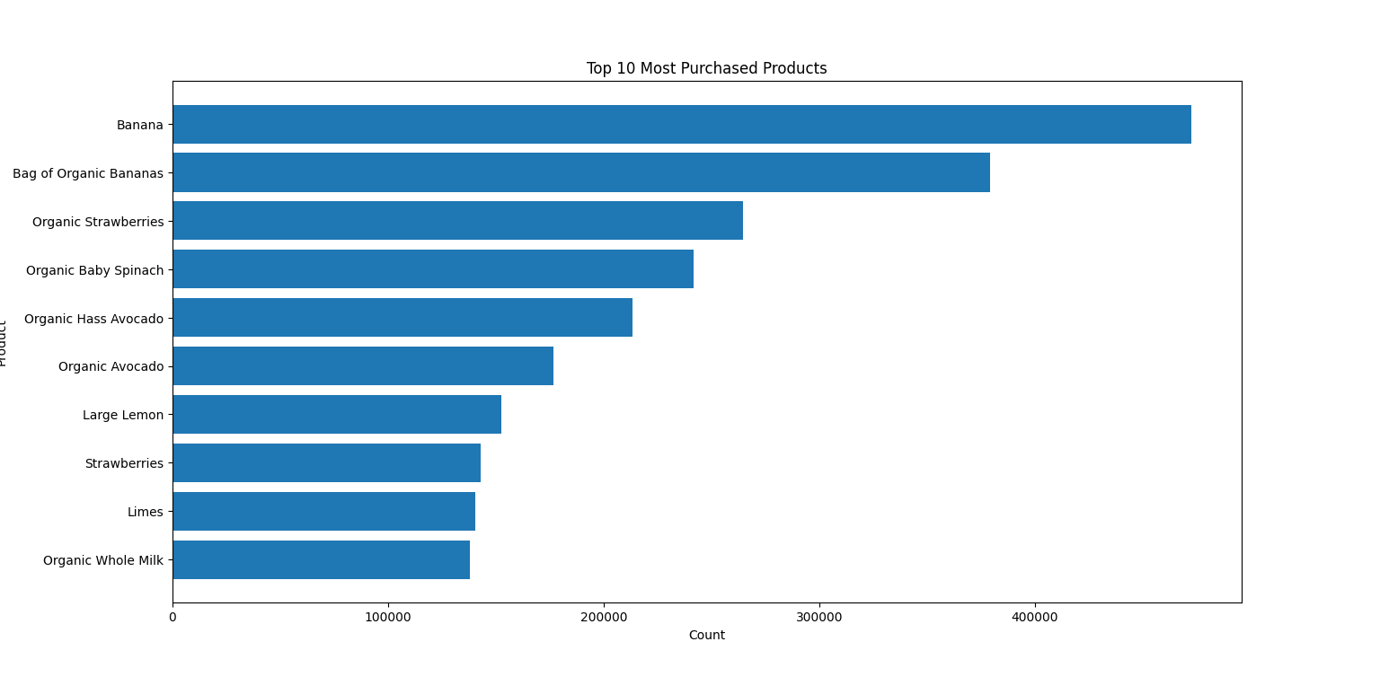

- Orders per User Distribution
Histogram of number of purchases per user
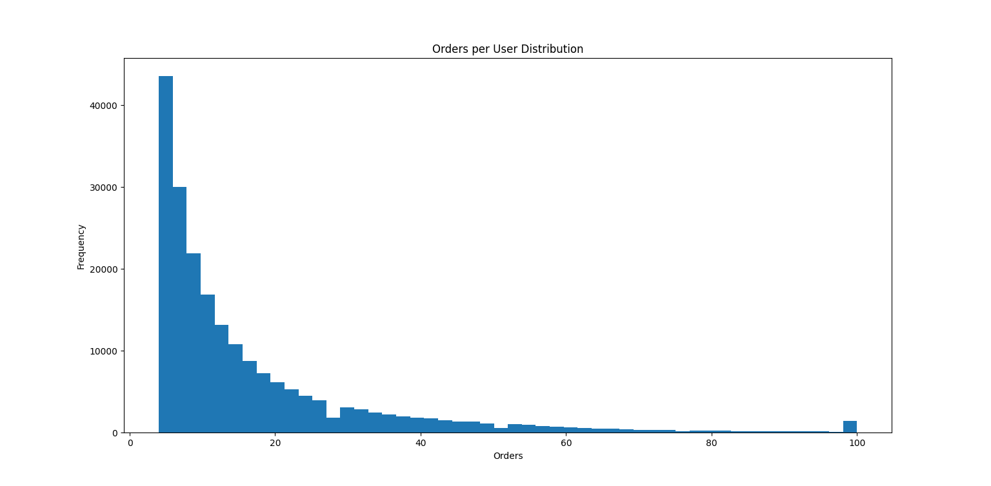
- Top active users
Bar chart of users with highest interactions
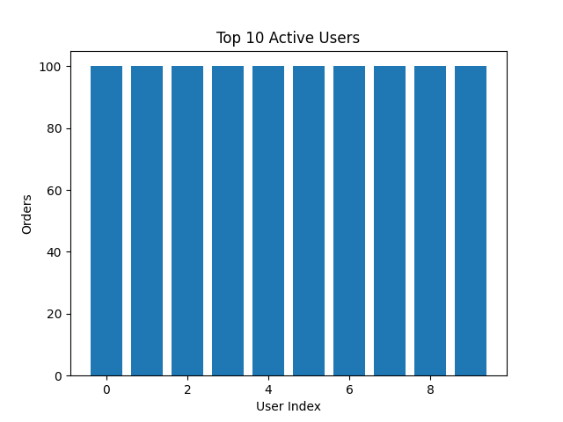
- Model Comparision graph
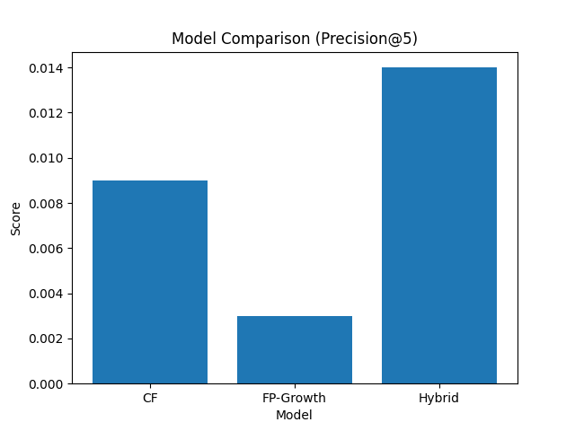


The scores represent the average recommendation strength generated by each model. The hybrid model achieves a higher score compared to individual models, indicating improved recommendation quality by combining similarity-based and association-based approaches.

Conclusion
This project successfully developed a hybrid E-commerce Product Recommendation System that provides personalized and relevant product suggestions. The system integrates Collaborative Filtering and the FP-Growth algorithm to capture both user preferences and product relationships.
Collaborative Filtering enables personalization by analyzing user interaction patterns, while FP-Growth identifies frequently co-purchased items from transaction data. By combining these techniques, the hybrid model overcomes limitations such as data sparsity and lack of diversity in recommendations.
The system was implemented using Python and optimized through preprocessing techniques such as filtering active users and frequently purchased products. The generated results demonstrate that the hybrid approach produces more meaningful and diverse recommendations compared to individual models.
Although traditional accuracy metrics were not applied due to the nature of recommendation systems, the model was evaluated based on the relevance and usefulness of recommendations. The results indicate improved performance of the hybrid model.
Overall, the project highlights the effectiveness of combining multiple recommendation techniques to enhance user experience, increase engagement, and support decision-making in e-commerce platforms.

References
- J. Han, M. Kamber, and J. Pei, Data Mining: Concepts and Techniques, 3rd ed., Morgan Kaufmann, 2011.
- B. M. Sarwar, G. Karypis, J. A. Konstan, and J. Riedl, “Item-Based Collaborative Filtering Recommendation Algorithms,” in Proceedings of the 10th International World Wide Web Conference, 2001.
- J. L. Herlocker, J. A. Konstan, A. Borchers, and J. Riedl, “An Algorithmic Framework for Performing Collaborative Filtering,” in Proceedings of the 22nd Annual International ACM SIGIR Conference, 1999.
- J. Han, J. Pei, and Y. Yin, “Mining Frequent Patterns without Candidate Generation,” in ACM SIGMOD International Conference on Management of Data, 2000.
- F. Pedregosa et al., “Scikit-learn: Machine Learning in Python,” Journal of Machine Learning Research, vol. 12, pp. 2825–2830, 2011.
- S. Raschka, “MLxtend: Providing Machine Learning and Data Science Utilities and Extensions to Python’s Scientific Computing Stack,” Journal of Open Source Software, 2018.

GitHub link:
https://github.com/sharun-g/ecommerce-recommendation-system.git

